**Savitribai Phule Pune University**



**Modern Education Society’s Wadia College of Engineering, Pune, 19, Bund Garden, V.K. Joag Path, Pune – 411001.**

**ACCREDITED BY NAAC WITH “A++” GRADE (CGPA – 3.13)**

# DEPARTMENT OF COMPUTER ENGINEERING

A REPORT ON

**DL Laboratory: Mini Project on**

**“Gender and Age Detection”**

# B.E. (COMPUTER)

*SUBMITTED BY*

**Onkar Gaikwad (F21112048)**

**Saniraj Desai (F21112051)**

**Swaraj Giri (F21112044)**

**Vinit Shingavi (F21112052)**

*UNDER THE GUIDANCE OF*

**Prof. S.K.Wagh**

# MES Wadia College of Engineering Pune-01 Department of Computer Engineering

|  |  |
| --- | --- |
| **Name of Student:** | **Class:** |
| **Semester/Year:** | **Roll No:** |
| **Date of Performance:** | **Date of Submission:** |
| **Examined By:** | **Experiment No: Mini Project** |

**ASSIGNMENT – Mini Project**

**AIM: Mini Project Implementation**

**TITLE: Gender and Age Detection**

**OBJECTIVES:**

* Understand deep learning methods for facial attribute classification using convolutional neural networks (CNNs).
* Learn how to detect and preprocess facial images from real-world datasets.
* Train custom CNN models to classify gender and age group from facial images.
* Evaluate and visualize the performance of the models using modern libraries and tools.

**APPRATUS:**

#### Hardware Requirements

1. Computer/Laptop:
   * **Processor: Intel i5 or equivalent and above**
   * **RAM: 8 GB or more recommended**
   * **Storage: Minimum 1 GB of free space for datasets and logs**

**Software Requirements**

1. **Operating System:**
   * Windows, Linux, or macOS (any OS that supports Python and OpenCV)
2. **Programming Language:**
   * Python 3.x
3. **Libraries and Frameworks:**
   * + **OpenCV:** For face detection and image processing
     + **TensorFlow / Keras:** For building and training CNN models
     + **NumPy:** For numerical computations and array manipulations
     + **Matplotlib:** For visualizing model training accuracy
     + **Sklearn:** For dataset splitting and evaluation utilities
     + **ImageDataGenerator (from Keras):** For image augmentation during training
4. **Other Tools:**
   * + **Jupyter Notebook, VS Code**, or any **Python IDE** for development and debugging
     + **Webcam (built-in or external):** For real-time face detection and prediction
     + **HDF5 Format Tools (optional):** For managing .h5 model files

# THEORY:

Age and gender detection is a computer vision task that involves classifying a person’s gender and estimating their age based on facial features using deep learning techniques. It is widely used in applications like targeted advertising, audience analytics, and surveillance systems.

1. Image Preprocessing:

Facial images are first resized to a consistent input size (e.g., 200x200 pixels) for the neural network. The images are normalized by scaling pixel values between 0 and 1 to improve learning efficiency. Face alignment and cropping may also be applied to focus on facial regions for better accuracy.

1. Convolutional Neural Networks (CNNs):

CNNs are deep learning models that are highly effective for image-based tasks. They learn hierarchical features such as edges, textures, and patterns from facial images. Separate CNNs or a shared CNN with different output layers can be used to predict both gender and age.

1. Model Architecture:

Typical CNN architectures involve multiple convolutional layers, followed by ReLU activation, pooling layers, and fully connected layers. For gender classification, the output layer has two units (male/female) with softmax activation. For age prediction, output can be a regression value (exact age) or a classification into age groups.

1. Training:

The model is trained using the UTKFace dataset, which contains labeled images of faces along with age and gender annotations. During training, the model learns to minimize loss functions:

* Categorical cross-entropy for gender classification
* Mean Squared Error (MSE) for age regression or categorical loss for age classification The dataset is split into training and validation sets to monitor generalization.

1. Inference:

After training, the model is used to predict age and gender on new facial images. The input image is passed through the trained CNN, which outputs the predicted gender and age. These predictions can be displayed in real-time using a webcam or applied to static images.

1. Evaluation:

Model performance is evaluated using accuracy for gender classification and MAE (Mean Absolute Error) or RMSE (Root Mean Square Error) for age prediction. Visual results are also analyzed by comparing predicted values with actual labels. Graphs showing loss and accuracy during training help assess the model’s learning behavior.

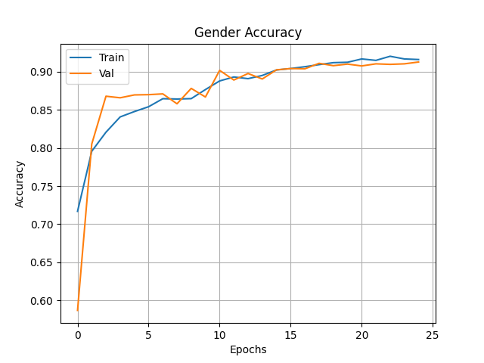

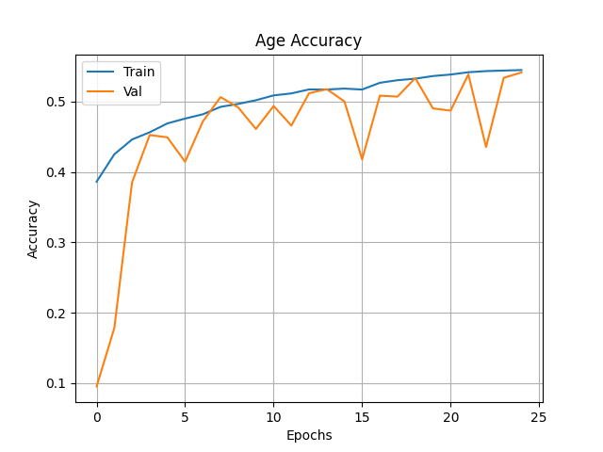

**DATA SET DESCRIPTION:**

* The dataset used for training is the UTKFace Dataset, which contains over 20,000 face images labeled with age, gender, and ethnicity.
* Each image file is named in the format:

age_gender_race_date&time.jpg

Example: 25_1_2_20170116174525125.jpg indicates a 25-year-old male of race 2.

* The dataset contains a wide age range (0 to 116 years) and binary gender labels:

0 for male

1 for female

* All images are cropped and aligned to focus on the face region, ensuring consistency in input.
* Images vary in size but are typically resized to 200x200 or 100x100 pixels during preprocessing to match the CNN input requirements.
* Basic data augmentation techniques such as horizontal flipping and rotation are applied to improve model robustness and prevent overfitting.
* The dataset includes diverse faces across different age groups, skin tones, and facial expressions, contributing to a more generalizable model.
* Some images may contain minor noise or occlusions (like glasses, hats), which simulate real-world conditions for better model performance

**INPUT:**

* **Input consists of RGB facial images** (.jpg format) taken from the UTKFace dataset or live webcam feed.
* Images may vary in resolution, but are **resized to a fixed size** (e.g., 100x100 or 200x200 pixels) before being passed to the CNN model.
* Each image contains **only one visible human face**, and the model detects and classifies **both age group and gender**.
* The input image is **normalized** by scaling pixel values to the range [0, 1] to maintain consistency during model inference.
* The system supports:

**Single image prediction** via file upload or webcam.

**Batch prediction** for testing multiple samples at once (optional)

* Input images must be **clear, front-facing, and well-lit** for accurate predictions.
* The model may not perform optimally on **blurred, occluded, or side-view images**, as it is trained on frontal facial images only.

**OUTPUT (SCREENSHOTS OF IMPLEMENTATION):**

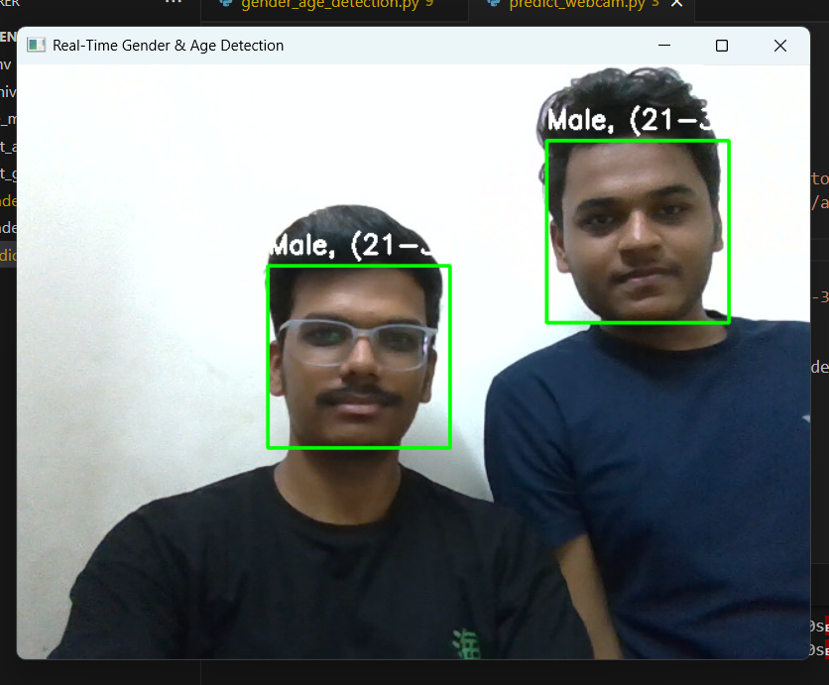

**CONCLUSION:**

This project successfully demonstrates the application of deep learning techniques for predicting **age group and gender** from facial images using the UTKFace dataset. By training custom Convolutional Neural Networks (CNNs), the system achieves reliable classification based on visual facial features.

Through this mini project, hands-on experience was gained in **data preprocessing, CNN architecture design, model training, and real-time prediction using webcam input**. The project also highlights the practical use of Python libraries like OpenCV, NumPy, and TensorFlow/Keras.

Future enhancements can include:

* **Improved model accuracy** using transfer learning with pre-trained models,
* **Age prediction as a regression task** for precise output,
* **Deploying the model on web or mobile platforms** for broader accessibility.

Overall, this project serves as a strong foundation for real-world facial analysis systems used in surveillance, user analytics, and personalized applications.